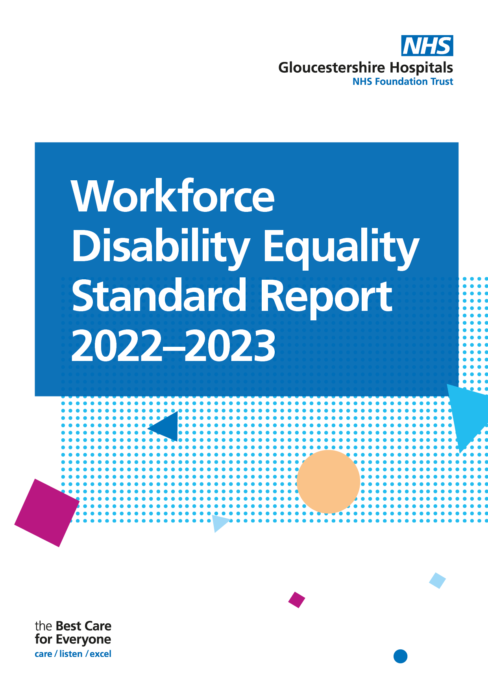

Introduction
Launched in 2019, the Workforce Disability Equality Standard (WDES) requires that all NHS organisations publish data and action plans against ten indicators of workforce disability equality, the aim being to improve the work experience of disabled staff. Each year, comparisons are made to enable the Trust to demonstrate progress against the indicators of disability equality. It also allows the Trust better understand the experiences of its disabled employees and support positive change for all by creating a more inclusive environment.

The data presented in this report will help the Trust create a more inclusive culture, by using a data driven approach to inform organisational change.

Workforce Data | Disabled | Non-Disabled | Unknown
 | 2.94% | 51.24% | 45.82%
Headcount
8095 | 238 | 4148 | 3709

WDES Metrics

WDES Metric | Disabled, Non-disabled & Disability Unknown or Null
1 | Percentage of staff in each of the AfC Bands 1-9 OR Medical and Dental subgroups and VSM (including executive Board members) compared with the percentage of staff in the overall workforce
2 | Relative likelihood of non-Disabled staff compared to Disabled staff being appointed from shortlisting across all posts
3 | Relative likelihood of non-Disabled staff compared to Disabled staff entering the formal capability process, as measured by entry into the formal capability procedure  (Metric based on data from a two-year rolling average)
4-9a | NHS Staff Survey data
9b | Has your organisation taken action to facilitate the voices of your Disabled staff to be heard?
10 | Percentage difference between the organisations’ Board voting membership and its overall workforce

Non-Clinical - Data Submission

Indicator 1 | Data Item | Disabled | Non-Disabled | Unknown/Null
1a) Non-Clinical Workforce  Percentage of staff in each of the AfC Bands 1-9 OR Medical and Dental subgroups and VSM (including executive Board members) compared with the percentage of staff in the overall workforce | Under Band 1 | 0 | 1 | 13
 | Band 1 | 0 | 1 | 3
 | Band 2 | 12 | 84 | 123
 | Band 3 | 24 | 285 | 235
 | Band 4 | 16 | 132 | 127
 | Band 5 | 6 | 88 | 73
 | Band 6 | 3 | 99 | 70
 | Band 7 | 5 | 39 | 35
 | Band 8a | 2 | 24 | 29
 | Band 8b | 4 | 18 | 16
 | Band 8c | 0 | 11 | 10
 | Band 8d | 0 | 6 | 6
 | Band 9 | 0 | 1 | 1
 | VSM | 0 | 5 | 1

Clinical WDES - Data Submission

Indicator 1 | Data Item | Disabled | Non-Disabled | Unknown/Null
1a) Non-Clinical Workforce  Percentage of staff in each of the AfC Bands 1-9 OR Medical and Dental subgroups and VSM (including executive Board members) compared with the percentage of staff in the overall workforce | Under Band 1 | 1 | 1 | 13
 | Band 1 | 0 | 1 | 3
 | Band 2 | 33 | 84 | 123
 | Band 3 | 14 | 285 | 235
 | Band 4 | 14 | 132 | 127
 | Band 5 | 35 | 88 | 73
 | Band 6 | 33 | 99 | 70
 | Band 7 | 13 | 39 | 35
 | Band 8a | 7 | 24 | 29
 | Band 8b | 2 | 18 | 16
 | Band 8c | 0 | 11 | 10
 | Band 8d | 0 | 6 | 6
 | Band 9 | 0 | 1 | 1
 | VSM | 0 | 5 | 1

Indicator 2 | Data Item | Disabled | Non-Disabled | Unknown/Null
2) Relative likelihood of Disabled staff compared to non-disabled staff being appointed from shortlisting across all posts. | Number of shortlisted applicants | 631 | 7719 | 426
 | Number appointed from shortlisting | 100 | 1703 | 204
 | Relative likelihood of non-disabled being appointed from shortlisting compared to disabled staff | 1.39

The relative likelihood of non-disabled staff being appointed from shortlisted compared to disabled staff ratio is 1.39. Disabled applicants are less likely to be appointed from shortlisting than non-disabled candidates.

Indicator 3 | Data Item | Disabled | Non disabled | Unknown/Null
3. Relative likelihood of non-Disabled staff compared to Disabled staff entering the formal capability process, as measured by entry into the formal capability procedure  (Metric based on data from a two-year rolling average). | Average number of staff entering formal capability process over the last 2 years for any reason (Total divided by 2) | 4.5 | 25 | 21.5
 | Of these, how many were on the grounds of ill health | 4.5 | 24.5 | 14
 | Likelihood of staff entering the formal capability process | 0 | 0.000121 | 0.002022

Those with an unknown disability are much more likely to enter the formal capability process.

Indicator 4 | Data Item | Disabled | Non disabled
Percentage of Disabled Staff compared to non-disabled staff experiencing harassment bullying or abuse from: | (1) Patients/Service users, their relatives or other members of the public | 36.2% | 27%
 | Managers | 20.7% | 11.8%
 | Other colleagues | 28.2% | 20.2%
Percentage of Disabled staff compared to non-disabled staff saying that the last time they experienced harassment bullying or abuse at work they or a colleague reported it. |  | 49.3% | 44.3%

Staff with a disability are more likely to have experienced harassment, bullying or abuse at work from there managers and other colleagues.

Disabled staff are more likely to report incidents of harassment, bullying or abuse compared to non-disabled.

Indicator 5 | Disabled | Non disabled
Percentage of Disabled staff compared to non-disabled staff believing that the Trust provides equal opportunities for career progression or promotion. | 44.5% | 51.9%

Equal opportunities for career progression or promotion – 44.5% of disabled staff (4% decrease 2021/22) believed they had equal opportunities for career progression or promotion. This compares to 51.9% of non-disabled staff.

Indicator 6 | Disabled | Non disabled
Percentage of Disabled staff compared to non-disabled staff saying that they have felt pressure from their manager to come to work, despite not feeling well enough to perform their duties. | 35.9% | 24.7%

35.9% of disabled staff say that they have felt pressured to come to work, despite not feeling well enough to perform their duties. This number has decreased compared to the previous year. Whereas the number has increased for non-disabled staff.

Indicator 7 | Disabled | Non disabled
Percentage of Disabled staff compared to non-disabled staff saying that they are satisfied with the extent to which their organisation values their work. | 27.2% | 34.8%

27.2% of colleagues with a disability feel that their work is valued compared with 34.8% of non-disabled colleagues. This is lower than the previous reporting period, where colleagues with disability were 29.4%.

Indicator 8 | Disabled
Percentage of Disabled staff saying that their employer has made adequate adjustment(s) | 72.3%
72.3% of colleagues with disability reported that they feel the Trust provides adequate adjustment(s). This has increased by 0.8% in the previous reporting period.
Indicator 9a | Org Overall | Disabled | Non-Disabled
The staff engagement score for Disabled staff, compared to non-disabled staff and the overall engagement score for the organisation | 6.3 | 5.9 | 6.4

Indicator 9b | Disabled
Has the organisation taken action to facilitate the voices of the disabled staff to be heard | Yes

The Trust’s inclusion network is made up of Ethnic minority, LGTBQ+ and Disabled staff where colleagues can raise concerns and discuss planned actions for its’ disabled colleagues.

The Trust has an established EDI steering group, providing the more senior leadership with time to focus on each strand of inclusion, including disability.

The Disability Network has made significant improvements moving the EDI agenda forward ensuring we continue to engage and evolve colleagues with disabilities and long-term conditions in our key decision making.

Indicator 10 | Data Item | Disabled | Non disabled | Unknown/Null
Board vs Organisational Workforce | Percentage difference between the organisation’s Board voting membership and its organisation’s overall workforce disaggregated. | -2.94% | -31.24% | 34.18%
 | Total Board members percentage by disability | 0% | 38.89% | 61.11%
The total Board members by percentage without disability is 38.89%, however, those who have not recorded their disability status is 61.11%.

