

**Clinical Audit On A Page**



**Title:**

**Project Lead and Team:**

**Registration Number:**

**Audit**  **Re-Audit**

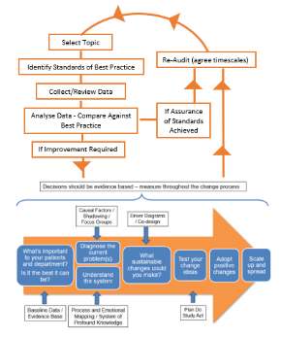

**Experience**

Please include insights gained through feedback from Parents and other service users. This could be via MVP, DadMatters, Patient experience team, complaints etc.

**Sharing and Presentation**

Include meeting name and date where results have been presented and any feedback from MDT discussion.

Please ensure results are shared with the clinical effectiveness team on completion

**Recommendations and Actions**

Actions required, who will be undertaking them, including ‘just do’ actions where there is a known and obvious ‘fix’ and QI project development where improvement can be achieved through testing and learning

If a Quality Improvement project is required, please ensure this is also registered. QI training and facilitation support can be accessed via the [Gloucestershire Safety and QI Academy (GSQIA)](https://www.gloshospitals.nhs.uk/work-for-us/training-staff/gsqia/)

|  |  |  |
| --- | --- | --- |
|  |  | Improvement required, priority topic, add to QI programme |
|  |  | Partial compliance / lower priority, add to QI programme |
|  |  | Good compliance achieved – reaudit within 3 years |
|  |  | Project closed |

⏹

**Data Collection / Methodology**

Retrospective / Prospective review, Timeframes audited (including year), Sample size, patient cohort, exclusions

**Reason for Audit**

Why was the audit needed? – e.g. mandatory national audit, 3 yearly review, re-issue or new guidance. Priority number of audit

**Related learning from local safety incidents**

**Priority level:**

**External ‘must do’ (1)**  **Internal ‘must do’ (2)**

**Important (3)**  **Interest (4)**

**Date started: / /**

**Audit Standards**

Please state the standards that is being audited against i.e the best practice/gold standard that should be being achieved, and include the threshold at which action is required for improvement. Please cite which professional body standards originate from

**Source of Standard:**  Trust Clinical Guideline  National Audit (Quality Account)  National Audit (Other)  NICE Guidance  NCEPOD  Other: (please specify)

**Results**

Compliance rates against best practice standards, key areas of good practice, areas where practice requires improvement / learning points.

In addition, all audit results must now include insights on ethnicity, language and deprivation

**The #GSQIAWay**

