

**How to:**

**Run Chart**

Line chart with median line to show the middle point of the data set. Data plotted over time to show baseline, measurement through the change process and whether improvements have been sustained

Arrange data into columns with column headers. If required sort the data to show consecutive data points from the earliest point in time through to the latest point in time.

Consecutive points - Could be numbers, dates, day of week, time during day etc

To Find the Median

Click on the cell where you want the median to be calculated (in this example, C2).

In the ‘Home’ tab in Excel, click on the downwards arrow to the right of ‘AutoSum’

Select ‘More Functions…’ and type ‘median’ into the ‘Search for a function box’

Highlight median and click ‘OK’

The ‘Function Arguments’ box is then shown. Highlight the data points you wish to calculate the median of (in this example B2:B21).

Click ‘OK’ and the median of the data set is shown in the cell you selected.

Copy the median result (Right click then ‘copy’, or Ctrl C (keyboard shortcut)) and select the next cell down (in this example C3)

Click on the drop down box under the ‘Paste’ option

And select the paste values option.

Copy this pasted value all the way down to the last data point.

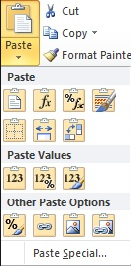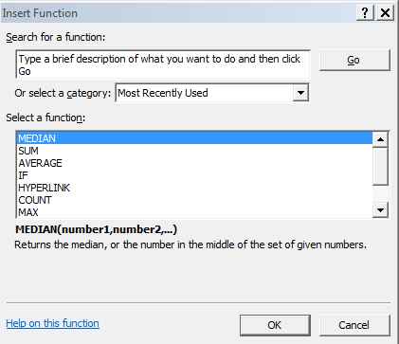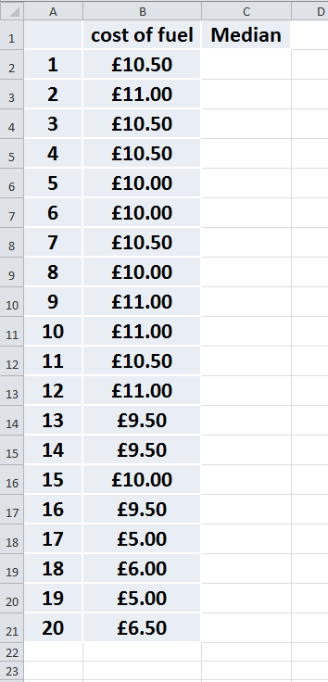

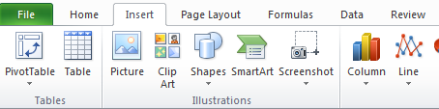

To Create the Graph

Highlight the data and median columns (including the column headers.

Select ‘Insert’ then the arrow under ‘Line’ and select desired chart

A run chart is created.

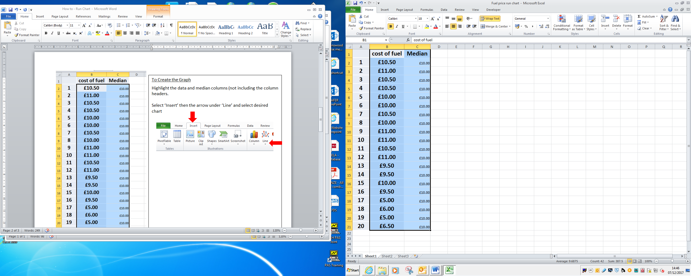

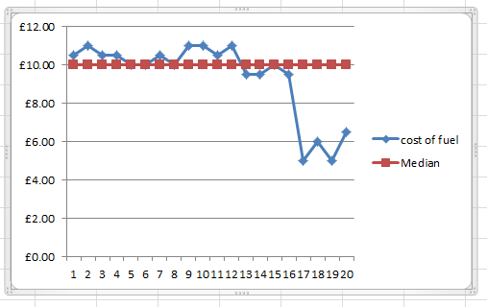

The legend, axes, line colour, line style and marker points can all be formatted to whatever you wish by selecting the desired item, then a right click to bring up the options.

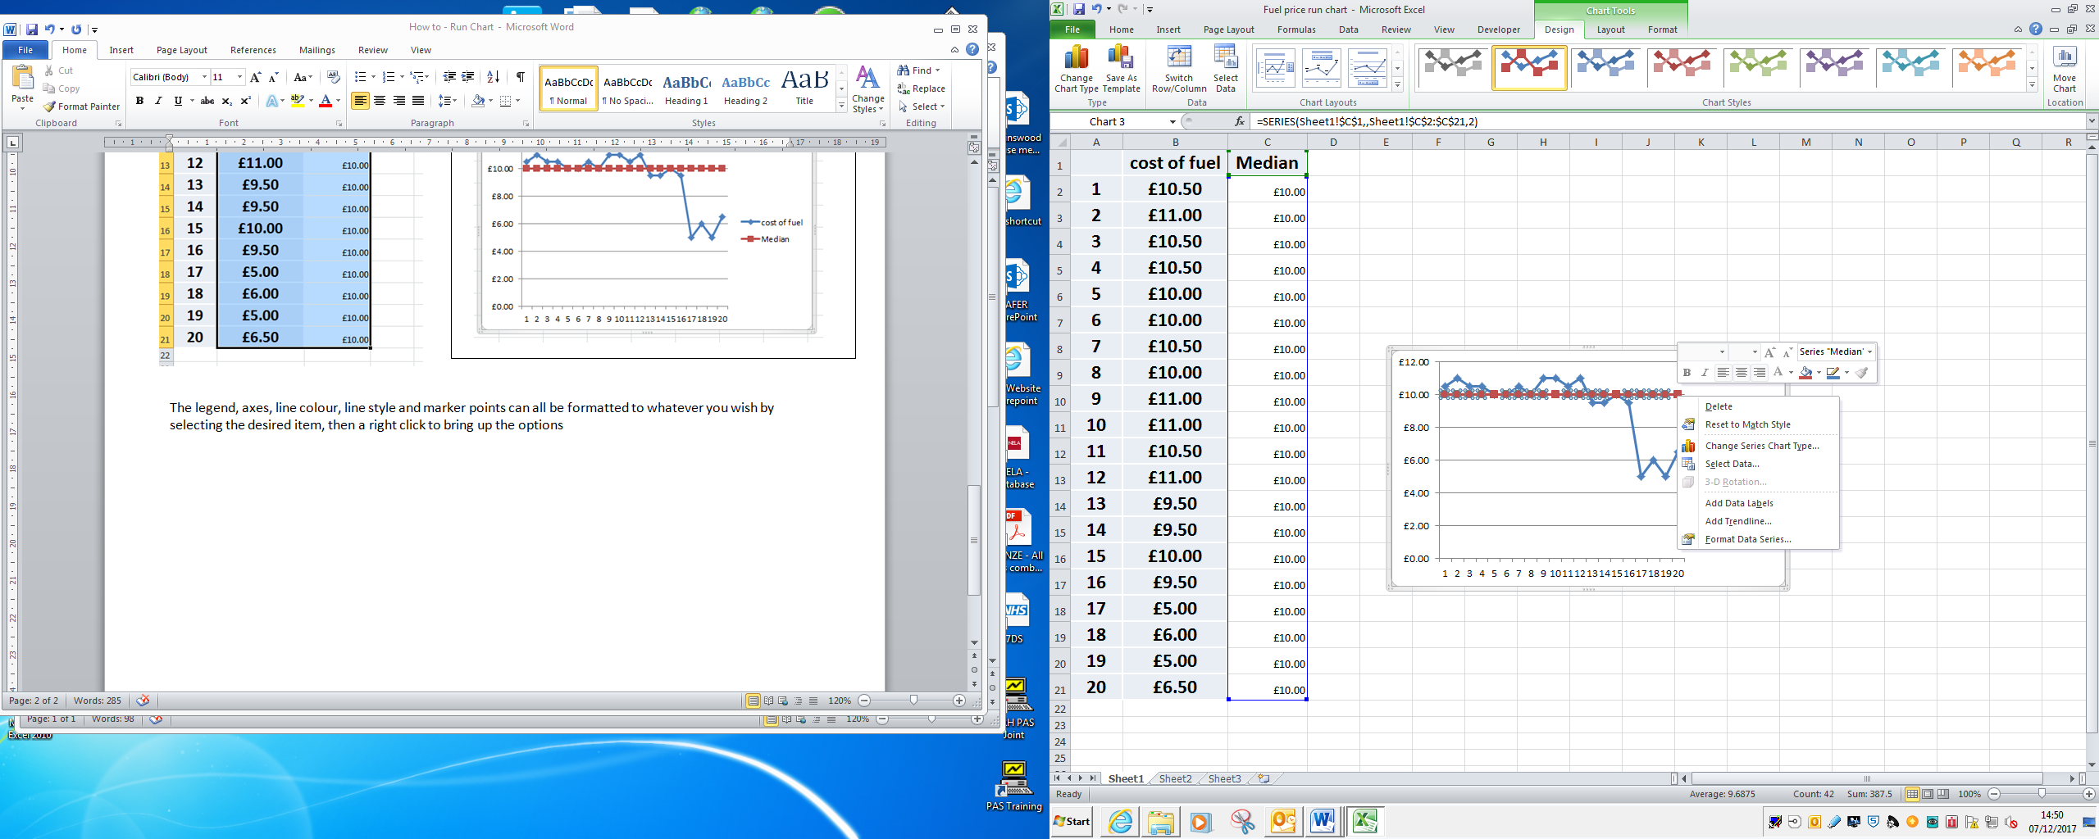

Additional columns can be added to create a ‘target’ line or to plot other measures, but try not to have too much detail on one graph.