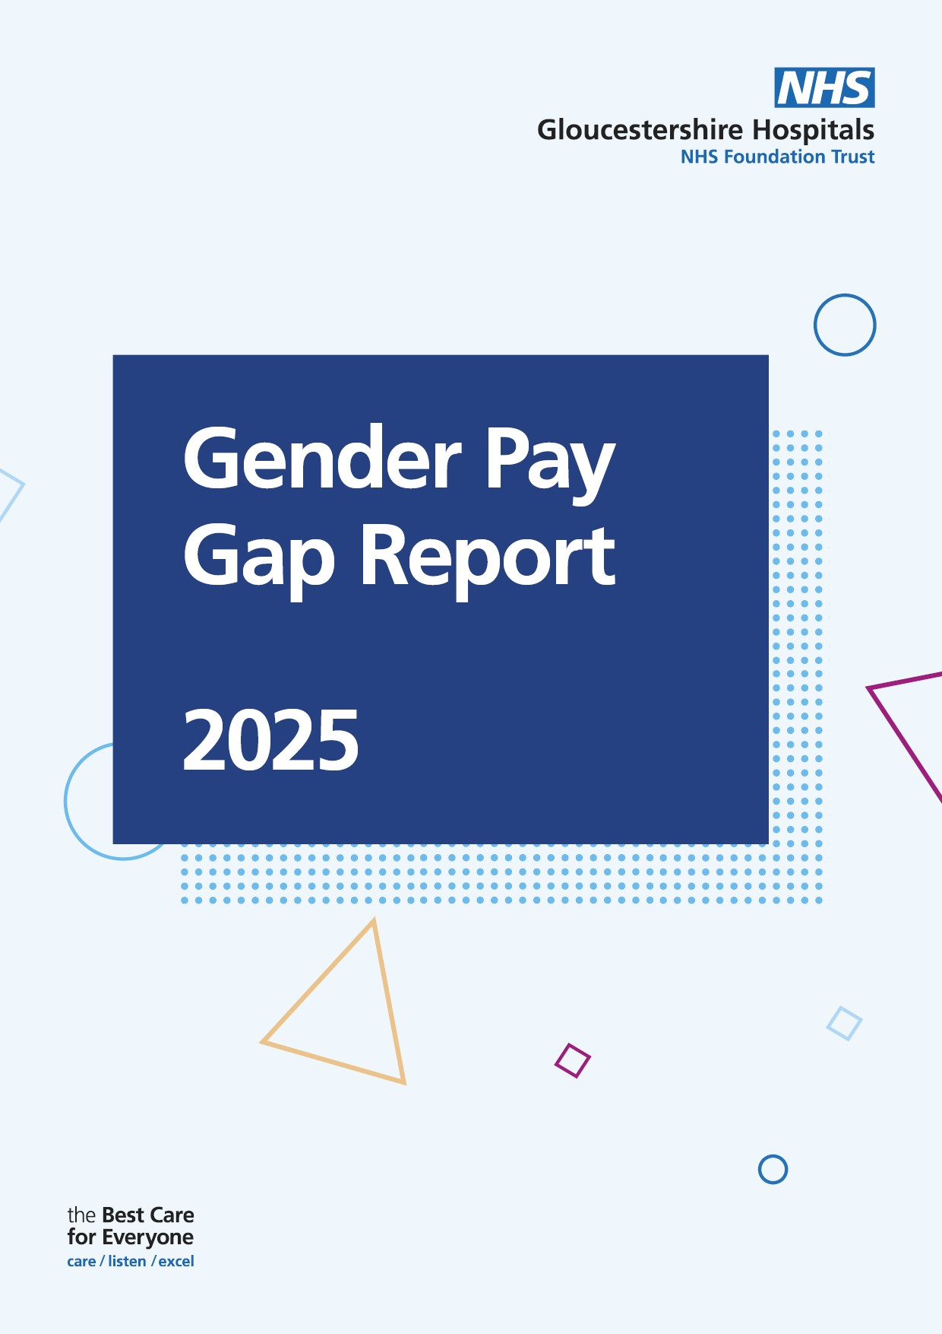

# Gloucestershire Hospitals Gender Pay Gap 2024

**Introduction**

The Equality Act 2010 (Specific Duties and Public Authorities) Regulations 2017 require public sector organisations with over 250 employees to report and publish their Gender Pay Gap (GPG) annually.

In 2023, guidance was introduced for voluntary Ethnicity Pay Gap (EPG) reporting. While the Trust is not yet required to publish ethnicity pay data, we have included an Ethnicity Pay Gap analysis at the end of this report.

We take pride in creating a workplace where staff and patients feel we provide equal opportunities and actively challenge discrimination. However, we recognise that there is still progress to be made. Addressing the GPG remains a priority, and we are committed to advancing equality, diversity, and inclusion across our workforce.

To continue improving the GPG, we will work to implement the recommendations outlined at the end of this report and remain dedicated to meaningful change.

At the time of compiling this report the Trust employed 9192 employees in a number of Staff Groups, including: bank staff, administrative; nursing; allied health; and medical roles. All staff except for medical and Very Senior Managers (VSMs) are on Agenda for Change pay-scales, which provide a clear process of paying employees equally, irrespective of their gender or ethnicity.

**What is the Gender Pay Gap**

The GPG measures the difference between the average (Mean or Median) earnings of men and women, expressed as a percentage of men’s earnings. For example, a 20% gap means that, on average, women earn 20% less than men.

When used effectively, GPG reporting serves as a valuable tool for evaluating workplace equality, assessing Women and Men’s participation, and understanding how well talent is being utilised

**What is the difference between the Gender Pay Gap and Equal Pay?**

The GPG is different from equal pay. Equal pay refers to the legal requirement to pay men and women the same for doing the same job, similar jobs, or work of equal value. It is unlawful to pay someone differently based on their gender.

In contrast, the GPG measures the average pay difference between all men and women across an organisation. A significant GPG may indicate underlying issues that need to be addressed, and detailed calculations can help identify specific areas for improvement. While the GPG may sometimes reflect unlawful pay inequality, this is not always the case.

**Managing Gender Pay Gap Reporting**

It is a legal requirement It is a legal requirement for all relevant employers to publish their gender pay report within one year of the ‘snapshot’ date. The GPG reporting period for the 23/24 reporting year, which uses a snapshot date of 31 March 2024 for the public sector, has a submission deadline of 30 March 2025.

Employers must follow the rules in the regulations to calculate the following information:

* The Trust’s Mean Gender Pay Gap
* The Trust’s Median Gender Pay Gap
* The Trust’s Mean Bonus Gender Pay Gap
* The Trust’s Median bonus Gender Pay Gap
* The proportion of Men receiving a Bonus payment
* The proportion of Women receiving a Bonus payment

**Who Is included?**

This report includes all relevant staff employed by the Trust on 31st March 2024, in line with GPG reporting requirements. This includes bank staff.

Pay data is based is sourced from the national Electronic Staff Record (ESR). As of this date, GHNHSFT data shows a 1.2% decrease in the proportion of women (previously 79.3% in 2023), with a corresponding increase in the proportion of men. This report fully complies with the Equality Act 2010 regulations, including the GPG Information Regulations 2017.

**What Pay Elements are included?**

The statutory calculations have been carried out using the standard national Electronic Staff Record (ESR)

In accordance with NHS Employers guidance, Clinical Excellence Awards and the methodology for awarding them have been classified as bonuses.

Pay includes basic salary, fully paid leave (such as annual leave, sick leave, maternity, paternity, adoption, or parental leave), Bonus pay and shift Pay. Most staff except medical staff, and very senior Managers were on the Agenda for Change pay scales.

**Executive Summary**

This is Gloucestershire Hospitals NHS Foundation Trust’s (GHNHSFT) GPG Report, based on a workforce snapshot as of 31 March 2024. At that time, GHNHSFT employed 9192 staff, with a workforce composition of approximately 78.1% women and 21.9% men.

**Key findings from March 2024 are as follows:**

* **The average Mean Gender Pay Gap for men is £6.05 or 23.3% higher, reflecting a 2.4% decrease from 25.7% in 2024.**
* **The Median Gender Pay Gap** **for men is £3.75 or 17.2% higher reflecting a 1.9% decrease from 19.1% in 2024.**

When excluding the medical and Dental staff, the mean GPG reduces to 0.62% (£0.11) in favour of men, meaning that, on average, men earn 0.62% more than women, equating to a small difference of 11p earned. This suggests near parity in average earnings.

The median GPG becomes 5.3% in favour of women, meaning that the middle-earning woman earns 5.3% more than men. Showing the data is mainly driven by the medical and dental awards. Therefore, excluding Medical, Dental staff and Clinical Excellence Awards (CEAs), the pay gap shifts significantly.

* **The Mean** **Gender Pay Gap reduces to 0.62% (£0.11) in favour of men.**
* **The Median Gender Pay Gap becomes 5.3%, (£0.87) in favour of women.**

Nationally, the GPG has been gradually decreasing, falling by about a quarter over the past decade among full-time employees, reaching 7.7% in April 2023.

The GPG has been declining slowly over time; over the last decade it has fallen by approximately a quarter among full-time employees, and in April 2023 it stands at 7.7%

**Key Findings Include:**

**Trust’s Gender Pay Gap summary:**

* The Trust’s Mean Gender Pay Gap is 23.3%
* The Trust’s Median Gender Pay Gap is 17.2%
* The Trust’s Mean Bonus Gender Pay Gap is 35.9%
* The Trust’s Median bonus Gender Pay Gap is 0.00%
* The proportion of Men receiving a Bonus payment is 64%
* The proportion of Women receiving a Bonus payment is 36%

The proportion of men and women for all staff in each quartile (Quartile 1 represents our lowest paid staff and Quartile 4 represents our highest paid staff).

* Quartile 1: 82.67% (1899 Headcount) Women and 17.33% (398Headcount) Men
* Quartile 2: 82.81% (1903 Headcount) Women and 17.19% (395 Headcount) Men
* Quartile 3: 82.33% (1892Headcount) Women and 41.47% (406.00 Headcount) Men
* Quartile 4: 64.72% (1488.00 Headcount) Women and 35.28% (811.00 Headcount) Men

**Workforce Overview**

Pay data is based on the period including the snapshot date of 31 March 2024, sourced from the national Electronic Staff Record (ESR). As of this date, GHNHSFT data shows a 1.2% decrease in the proportion of women (previously 79.3% in 2023), with a corresponding increase in the proportion of men. The report complies fully with the Equality Act 2010 **r**egulations, including the GPG Information Regulations 2017.

For this report the numbers have all been rounded to 1 decimal place. This may mean that the accumulative figures add up slightly more of less than 100.

|  |  |  |  |  |  |
| --- | --- | --- | --- | --- | --- |
| Workforce Data | 2024 Headcount | 2024% | 2023 Headcount | 2023% | % Difference |
| Total Workforce | 9192 |  | 8830 |  | Increase of 4.1% compared to the 2023 data. |
| Men | 2010 | 21.9% | 1831 | 20.7% | Increase of 1.2% compared to 2023 |
| Women | 7182 | 78.1% | 6999 | 79.3% | Decrease of 1.2% compared to the 2023 data. |

The total workforce increased by 4.1% from 2023 to 2024, growing from 8,830 to 9,192 employees. Men rose by 1.2%, from 20.7% to 21.9% of the total workforce, while the number of women employees grew slightly in absolute terms, from 6,999 to 7,182. However, due to the overall workforce increase, the percentage of women decreased by 1.2%, from 79.3% to 78.1%.

**Gender Pay Gap – All Staff**

|  |  |  |
| --- | --- | --- |
| **Difference in Pay** | **Gender Pay Gap** | **Compared to 2023** |
| Mean hourly pay for men **£6.05** higher than Women | Gender Pay Gap of 23.3% | Decrease of 2.4% *(25.7% in 2023)* |
| Median hourly pay for men **£3.75** higher than Women | Gender Pay Gap of 17.2% | Decrease of 1.9% *(19.1% in 2023)* |

* Mean (Average) Gender Pay Gap: Men earn an average of £26.00 per hour, while women earn £19.94 per hour—a difference of £6.05 or 23.3%. This represents a 2.4% improvement from 2023.
* Median Gender Pay Gap: Men earn £3.75 more per hour than women, resulting in a median pay gap of 17.2%. This reflects a 1.9% improvement from 2023.

**Gender Pay Gap – Excluding Medical and Dental Staff**

|  |  |  |
| --- | --- | --- |
| **Difference in Pay** | **Gender Pay Gap** | **Compared to 2023** |
| Mean hourly pay for men **£0.11** higher than women | Gender Pay Gap of 0.62% | Decrease of 1.3% (1.90% in 2023) |
| Median hourly pay for men -**£0.87** higher than women | Gender Pay Gap of -5.3% | Decrease of 0.5% *(-4.85% in 2023)* |

**When medical and dental staff are excluded:**

* Mean (Average) Gender Pay Gap: Men earn an average of £18.30 per hour, while women earn £18.19 per hour—a difference of £0.11 or 0.62%. This marks a 1.3% improvement from 2023.
* Median Gender Pay Gap: Women earn more on average, with men earning £16.30 per hour and women earning £17.17 per hour, resulting in a gender pay gap of -5.3% in favour of women.

**Medical Staff Only**

|  |  |  |
| --- | --- | --- |
| **Difference in Pay** | **Gender Pay Gap** | **Compared to 2023** |
| Mean hourly pay for men **£40.34** higher than women | Gender Pay Gap of 17.3% | Decrease of 0.7% (18.0% in 2023) |
| Median hourly pay for men **£31.47** higher than women | Gender Pay Gap of 2.6% | Decrease of 4.2% *(6.8% in 2023)* |

When this group is analysed in isolation:

* Mean Gender Pay Gap for Medical Staff: Male medical staff earn an average of £40.34 per hour, while women earn £33.36 per hour—a difference of £7.01, resulting in a pay gap of 17.3%.
* Median Gender Pay Gap: Men earn £31.47 per hour, whereas women earn £30.65 per hour—a gap of £0.82 or 2.6%.

**Pay Quartiles**

We are required to split the workforce into quartiles (blocks of 25%) split by pay and show proportions of men and women.

The chart below shows the percentage distribution of men and women across pay quartiles. Women dominate the lower, lower middle, and upper middle quartiles, making up over 82% in each, while men account for around 17% in these categories.

However, in the upper quartile, women representation drops to 64.72%, with men occupying 35.28% of the highest-paid roles. This indicates that men are more concentrated in senior, higher-paying positions, while women are more evenly distributed across lower-paid roles.

Across all pay quartiles (from lower to upper), women represent a significantly larger proportion compared to men, consistently making up around 82% to 85 of the workforce in each quartile. This suggests that non-medical roles within this organisation are heavily dominated by women, regardless of pay level.

**Percentage of Gender in pay quartiles no medical Staff**

**Medical Staff Only**

Across all pay quartiles (from lower to upper), women make up the majority, consistently comprising around **59% of the workforce** in the lower to middle pay levels. However, in the top quartile (highest pay levels), men become the majority, representing **61% of the workforce.** This indicates that while women dominate the lower and middle pay levels, men are more prevalent in higher pay levels

**Clinical Excellence Awards Bonus Payments**

Local Clinical Excellence Award’s (LCEA) recognise and reward NHS consultants in England, who perform over and above the standard expected of their role. Awards are given for quality and excellence, acknowledging exceptional personal contributions.

In 2024, 399 bonus payments were made to Medical and Dental staff:

* + 64% awarded to men
  + 36% awarded to women
* Mean Bonus Pay Gap: Male Consultants earned an average bonus of £8,802.24, compared to £5,644.48 for women – a 35.90% pay gap.
* Median Bonus Pay Gap: No gap using the median calculation.

The statistics point to a potential imbalance in how bonus payments are awarded, with men receiving a larger share both in terms of the number of bonuses and the average value of these payments.

The tables below detail bonus pay as Local Clinical Excellence Awards (LCEA), as with the median hourly rate of pay, this is based on the mid-point of all staff receiving bonus pay.

**Average CEA Bonus Gender Pay Gap as a mean and median average Consultants**

|  |  |  |  |  |  |  |
| --- | --- | --- | --- | --- | --- | --- |
|  | Role | Men | Women | Total | % Men | % Women |
| 2024 | Consultant | **255** | 144 | 399 | 63.9% | 36.1% |
| 2023 | Consultant | 131 | 63 | 194 | 67.5% | 32.5% |
| 2022 | Consultant | 125 | 59 | 184 | 67.7% | 32.5% |

The Trust is committed to reducing the GPG We have outlined key initiatives and will continue to explore further opportunities through local, regional, and national programmes. Whilst we have seen gradual progress, we recognise that addressing the gap will take time. Historical contractual practices in the medical and dental sectors, as well as broader societal gender inequalities, continue to influence the situation.

Women often face additional challenges, such as unpaid caregiving responsibilities, which can result in career breaks, part-time work, and occupational segregation, where men dominate certain roles that are valued differently. Despite these challenges, we remain dedicated to driving change and making continued progress toward gender equality.

**Conclusion**

In 2024, the Trust's GPG stands at 23.3%, showing a decrease from the previous year's figure of 25.7%. While this reduction is a positive development, it is important to note that the gender pay gap does not equate to unequal pay for equal work. Unequal pay, which involves paying individuals differently for doing the same job based on their gender, would be unlawful. Instead, the gender pay gap arises due to the fact that men are more commonly found in higher-paid roles within the Trust, while women tend to occupy lower-paid positions.

The demographic composition of the Trust reflects broader trends seen across the NHS, with women making up 78.1% of the workforce and men comprising 21.9%. While this gender distribution is relatively in line with national NHS figures, it highlights a significant disparity in the representation of men and women across various job grades. Specifically, there are proportionately more women in lower pay bands and, conversely, more men in higher pay bands. This imbalance contributes to the overall gender pay gap, as men, on average, hold roles that command higher salaries, while women are overrepresented in lower-paying roles.

Efforts to address this GPG must focus not only on closing the disparity in the representation of men and women across different job bands but also on supporting women’s advancement into higher-paid roles. This includes ensuring equal access to development opportunities, mentorship, and leadership positions that enable women to progress in their careers.

**Recommendations and Actions**

|  |  |
| --- | --- |
|  |  |
| **1.** | **Develop targeted actions:** Integrate findings into the Equality, Diversity, and Inclusion (EDI) priorities for 2023–24. And the coming years |
| **2.** | **Track progress:** Monitor initiatives through the EDI Steering Group, reporting to the People and Organisational Development Committee. |
| **3.** | **Engage staff**: Collaborate with female staff to address barriers to progression and identify opportunities for development. |
| **4.** | **Equality Impact Assessment** Use Equality Impact Assessments to monitor and review recruitment and promotion policies and processes to ensure any barriers to recruitment or promotion are identified and removed |
| **5.** | **Women’s Network;** The Women’s Network will officially launch in March 2025, with an executive sponsor and two co-chairs already appointed. This initiative aims to create a supportive community that empowers women within the organisation, encourages networking opportunities, and promotes professional growth. The network will provide a platform for women to connect, share insights, and collaborate on initiatives that drive EDI across all levels of the organisation. |
| **6.** | **Sexual Safety Charter:** The Trust is dedicated to tackling sexism and sexual harassment in the workplace by identifying and challenging inappropriate behaviours. A Sexual Behaviour Policy is currently being developed. |
| **7.** | **Explore male-focused initiatives:** We will revisit the feasibility of establishing a men's health network. While there has been limited interest in starting a dedicated network so far, we will continue to raise awareness of the importance of having conversations around men’s mental health and health. |

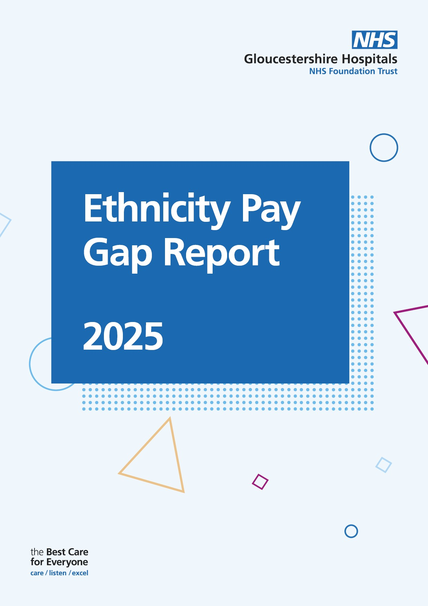

# Gloucestershire Hospitals Ethnicity Minority Pay Gap 2024

Data reported as at 31 March 2024, unless otherwise indicated.

**Summary**

The Ethnicity Pay Gap ((EPG)) is based on a snapshot of all GHFT Ethnic Minority (EM) employees on the 30 March 2024. On that date, GHFT employed 9,192. As the 31st March, GHFT employed 22% of EM staff and 67% of White Staff. Please note 11% ethnicity is unknown.

**For the purpose of this report, the term "Ethnic Minority" will be used to refer to our Black and Asian staff. This terminology has been chosen for consistency within the report; however, we acknowledge the evolving discussions around language and inclusivity**.

**Gloucestershire Demographics (Census 2021)**

* 6.9% of the population of Gloucestershire is ethnically diverse.
* 15.1% of the population of Gloucester is ethnically diverse.
* 8.6% of the population of Cheltenham is ethnically diverse

**Introduction**

Unlike the GPG, there is no legal requirement in the UK to conduct an ethnicity pay gap (EPG) report. The Government did however, publish the first report in 2017 to examine the barriers EM face in employment in its ‘Race in the Workplace report.

The Trust sees this as an opportunity to build stronger relationships with our workforce and beyond through openness and transparency, as well as demonstrating our commitment to consistently improve.

Reporting our EPG aims to support analysis and use of the resulting information to produce effective action plans. These will be used to address any gaps in pay within the ethnic group’s EPG

**What is the Ethnicity Pay Gap**

The ethnicity pay gap is different to equal pay. Ethnic pay disparities are not primarily about those from a white background and other ethnic groups being paid differently for the same job. The Equality Act 2010 make it unlawful to discriminate (both directly and indirectly) against employees because of their race. Analysing the EPG will help the Trust to better understand the extent of the pay gap amongst staff to raise awareness and focus on actions to close the gap and monitor improvement.

As of March 2024, 22% of staff at GHNHSFT identified as being from an EM background, 66.84% of the workforce is White, and 11% had their ethnicity recorded as unknown

The table below shows the average and median hourly rates for different ethnic origins groups as follows.

|  |  |  |
| --- | --- | --- |
| **Ethnic Origin Grouping Summary** | **Avg. Hourly Rate** | **Median Hourly Rate** |
| BME | £22.18 | £19.48 |
| NULL | £18.85 | £16.11 |
| Not Stated | £20.76 | £18.98 |
| Other | £24.32 | £21.80 |
| White | £21.49 | £18.50 |

The mean pay gap between EM and White staff shows that EM employees earn an average hourly rate of £22.17, while White staff earn £21.49. This results in a difference of £0.68, representing a gap of 3.2%.

The median pay gap reveals that EM staff earn £19.48 per hour, compared to £18.50 for White staff. The difference is £0.98, equating to a gap of 5.25%.

* The mean average for NULL is £18.85 and median of £16.11.
* The mean average for Not Stated is £20.76 and median £18.98.
* The mean average for Other is £24.32 and median £21.80

Staff who did not declare or have an unspecified ethnicity tend to have higher earnings, while White staff earn the least on average.

**Pay Quartiles**

This data shows the distribution of individuals in different ethnic groups across four pay quartiles (1 to 4). These quartiles represent salary bands, with Quartile 1 being the lowest and Quartile 4 being the highest. The numbers show how many individuals from each ethnic group are in each quartile.

|  |  |  |  |  |  |  |  |  |
| --- | --- | --- | --- | --- | --- | --- | --- | --- |
| **Quartile** | **Asian** | **Black** | **Mixed** | **NULL** | **Not Stated** | **Other** | **White British** | **White Other** |
| **1** | 196 | 81 | 44 | 98 | 122 | 28 | 1,649 | 104 |
| **2** | 372 | 113 | 41 | 167 | 202 | 36 | 1,266 | 126 |
| **3** | 385 | 125 | 32 | 58 | 213 | 48 | 1,356 | 106 |
| **4** | 313 | 102 | 58 | 61 | 139 | 47 | 1,457 | 146 |

**Quartile 1** - **White British** individuals make up a large portion of the lowest-paid employees (1,649 individuals). However, there are also a notable number of individuals who have not stated their ethnicity (122), as well as a significant number of **Asian** employees (196).

**Quartile 2** - **White British** staff are still the largest group, but the number has decreased (1,266). The number of **Asian** employees increases here (372), and there are also more **Black** staff (113) compared to Quartile 1.

**Quartile 3** - **White British** employees still make up the largest group, but the number is slightly less than in the previous quartiles (1,356). **Asian** (385) and **Black** (125) staff make up a substantial part of this quartile as well.

**Quartile 4** - **White British** staff are still the largest group (1,457). There are fewer **Asian** (313) and **Black** (102) staff in the highest salary range compared to the lower quartiles

White British staff are the largest ethnic group across all pay quartiles, with Asian individuals following. Black and Mixed groups have smaller representation, peaking in **Quartile 2**. A significant number of staff haven't stated their ethnicity, particularly in **Quartiles 2** **and 3.** There are fewer people in the "Other" category, with their numbers remaining consistent across the quartiles.

**Ethnicity Local Clinical Excellence Awards Bonus Payments** **2024**

**Average LCEA Bonus Gender Pay Gap as a mean and median average Consultants**

**399** bonus payments were made to medical and dental staff: in 2024. There are **295 (74%)** white consultants, compared to **89 (23%)** EM Consultants and **14 (4%)** of those not stated their ethnicity.

|  |  |  |  |  |  |  |
| --- | --- | --- | --- | --- | --- | --- |
| Year | Role | Total | White | EM | % White | % EM |
| **2025** | **Consultant** | **399** | **295** | **89** | **74%** | **23%** |

**Conclusion**

The Gloucestershire Hospitals NHS Foundation Trust EPG pay gap **at March 2024** is reported at:

* **Mean** **Ethnicity Pay Gap, 3.2% in favour of EM Staff**
* **Median Ethnicity Pay Gap, 5.3% in favour of EM Staff**

These figures reflect the **combined** Ethnicity Pay Gap of all staff.

Based on the current data, EM staff are paid slightly more than white staff. There could be several reasons for this. BME staff may remain longer within a pay band, progressing through the band's incremental points. In contrast, white staff are more likely to be promoted to higher bands, although they may start at lower incremental points.

With regards to the Ethnicity Bonus Pay Gap. The data shows that among 399 consultants, 74% identify as White, while 23% identify as EM. This indicates that White Consultants continue to make up the majority of the Consultant roles, though there is representation from EM.

Further analysis may be needed to understand factors influencing this distribution, such as recruitment, progression opportunities, and retention within these roles.

**Recommendations and Actions**

|  |  |
| --- | --- |
|  |  |
| 1. | **Inclusion Network:** Invited members of staff to safely have conversations about race through the Inclusion Network |
| 2. | **Knowledge Sharing:** A pilot knowledge-sharing session was held, providing colleagues with a safe space to learn about different religions and topics of interest, while confidently asking questions.  The first session in November 2024 focused on learning about Islam, with a session on Sikh beliefs scheduled for April. Plans are in place to host additional sessions on topics of interest throughout 2025. |
| 3. | **Equality Impact Assessment:** A Task and Finish group has been established to revise the outdated EIA form. The updated form will support staff in effectively assessing the impact of policies, projects, and decisions on different groups, promoting inclusivity, equality, and informed decision-making across the organisation. |
| 4. | **Training: Interviewing with Impact:** low attendance for the Pilot Interviewing with Impact workshop in August 2024. However, there is now renewed interest in holding another workshop in April.  **Managers Development Programme. (MDP):** MDP training programme is currently being developed to support both new and existing managers. As part of this initiative, an important component will focus on EDI training. This EDI element will be designed to equip managers with the knowledge and tools to best understand best practice in promoting fairness and diversity within their teams.  The training will help managers to enhance their leadership skills by addressing potential biases, improving team dynamics, and supporting a culture of inclusion and respect.  The Inclusive Culture workshop has been successfully launched as part of the Developing Leaders Programme. |
| 5. | **EDI/Recruitment:** Both teams are collaborating to develop a more equitable and unbiased recruitment process.  Inclusion champion training is currently being developed for both existing champions and those new to interviewing. |
| 6. | **Electronic Staff Record:** Collecting and updating staff demographic information, such as ethnicity and disability status, is vital for maintaining a fair, inclusive, and supportive workplace. It also plays a key role in identifying and addressing pay gaps, ensuring greater pay equity across the Trust  Staff are encouraged to update their ESR when applying to join the network.  A video with step-by-step instructions on updating ESR is being shared through the Inclusion Network. |

**\*GPG Report Pending Approval\***